Name: Suyash Singh Tomar CU24250178 sec:B roll no: 60
import pandas as pd import numpy as np
import matplotlib.pyplot as plt import seaborn as sns
from sklearn.preprocessing import LabelEncoder, StandardScaler print("liberaries are installed ") liberaries are installed
df =
pd.read_csv("/workspaces/Mastery_in_DataAnalytics_and_Visualizations_a nd_Career_Advancemen/train-selected-columns.csv")
print("First 5 rows:") print(df.head())
print("\nDataset Information:") df.info()
print("\nStatistical Description:") print(df.describe())
First 5 rows:
PassengerId Survived Pclass \
- 1 0 3
- 2 1 1
- 3 1 3
- 4 1 1
- 5 0 3
Name Sex Age
SibSp \
Braund, Mr. Owen Harris male 22.0
Cumings, Mrs. John Bradley (Florence Briggs Th... female 38.0
Heikkinen, Miss. Laina female 26.0
Futrelle, Mrs. Jacques Heath (Lily May Peel) female 35.0
Allen, Mr. William Henry male 35.0
0
1
1
1
2
0
3
1
4
0
Parch Ticket Fare
- 0 A/5 21171 7.2500
- 0 PC 17599 71.2833

- 0 STON/O2. 3101282 7.9250
- 0 113803 53.1000
- 0 373450 8.0500
Dataset Information:
<class 'pandas.DataFrame'>
RangeIndex: 891 entries, 0 to 890 Data columns (total 10 columns):
# Column Non-Null Count Dtype
--- ------ -------------- -----
- PassengerId 891 non-null int64
- Survived 891 non-null int64
- Pclass 891 non-null int64
- Name 891 non-null str
- Sex 891 non-null str
- Age 714 non-null float64
- SibSp 891 non-null int64
- Parch 891 non-null int64
- Ticket 891 non-null str 9 Fare 891 non-null float64 dtypes: float64(2), int64(5), str(3) memory usage: 69.7 KB
Statistical Description:
PassengerId Survived Pclass Age SibSp \ count 891.000000 891.000000 891.000000 714.000000 891.000000 mean 446.000000 0.383838 2.308642 29.699118 0.523008 std 257.353842 0.486592 0.836071 14.526497 1.102743 min 1.000000 0.000000 1.000000 0.420000 0.000000 25% 223.500000 0.000000 2.000000 20.125000 0.000000
50% 446.000000 0.000000 3.000000 28.000000 0.000000 75% 668.500000 1.000000 3.000000 38.000000 1.000000 max 891.000000 1.000000 3.000000 80.000000 8.000000
Parch Fare count 891.000000 891.000000 mean 0.381594 32.204208 std 0.806057 49.693429 min 0.000000 0.000000 25% 0.000000 7.910400
50% 0.000000 14.454200 75% 0.000000 31.000000 max 6.000000 512.329200
print("Dataset Information:") df.info()
Dataset Information:
<class 'pandas.DataFrame'>
RangeIndex: 891 entries, 0 to 890

Data columns (total 10 columns):
# Column Non-Null Count Dtype
--- ------ -------------- -----
- PassengerId 891 non-null int64
- Survived 891 non-null int64
- Pclass 891 non-null int64
- Name 891 non-null str
- Sex 891 non-null str
- Age 714 non-null float64
- SibSp 891 non-null int64
- Parch 891 non-null int64
- Ticket 891 non-null str 9 Fare 891 non-null float64 dtypes: float64(2), int64(5), str(3) memory usage: 69.7 KB
print("Statistical Description:") df.describe()
Statistical Description:
PassengerId Survived Pclass Age SibSp \
count 891.000000 891.000000 891.000000 714.000000 891.000000 mean 446.000000 0.383838 2.308642 29.699118 0.523008 std 257.353842 0.486592 0.836071 14.526497 1.102743 min 1.000000 0.000000 1.000000 0.420000 0.000000 25% 223.500000 0.000000 2.000000 20.125000 0.000000
50% 446.000000 0.000000 3.000000 28.000000 0.000000 75% 668.500000 1.000000 3.000000 38.000000 1.000000 max 891.000000 1.000000 3.000000 80.000000 8.000000
Parch Fare count 891.000000 891.000000 mean 0.381594 32.204208 std 0.806057 49.693429 min 0.000000 0.000000 25% 0.000000 7.910400
50% 0.000000 14.454200 75% 0.000000 31.000000 max 6.000000 512.329200
print("Dataset Shape:") print(df.shape)
Dataset Shape:
(891, 10)
print("Missing Values:") print(df.isnull().sum())

Missing Values:
PassengerId 0
Survived 0
Pclass 0
Name 0
Sex 0
Age 177
SibSp 0
Parch 0
Ticket 0
Fare 0
dtype: int64
print("Missing Value Percentage:") print((df.isnull().sum() / len(df)) * 100)
Missing Value Percentage:
PassengerId 0.00000
Survived 0.00000
Pclass 0.00000
Name 0.00000
Sex 0.00000
Age 19.86532
SibSp 0.00000
Parch 0.00000
Ticket 0.00000
Fare 0.00000
dtype: float64
print("Duplicate records before removal:") print(df.duplicated().sum()) df.drop_duplicates(inplace=True)
print("Duplicate records after removal:") print(df.duplicated().sum())
Duplicate records before removal:
0 Duplicate records after removal:
0
df =
pd.read_csv("/workspaces/Mastery_in_DataAnalytics_and_Visualizations_a nd_Career_Advancemen/train-selected-columns.csv") print(df.columns.tolist())
['PassengerId', 'Survived', 'Pclass', 'Name', 'Sex', 'Age', 'SibSp',
'Parch', 'Ticket', 'Fare']

df.to_csv("cleaned_train.csv", index=False) print("Cleaned dataset saved successfully!")
Cleaned dataset saved successfully!
# Check duplicate records
print("Duplicate records before removal:") print(df.duplicated().sum())
# Remove duplicate records df.drop_duplicates(inplace=True)
# Check duplicates again
print("\nDuplicate records after removal:") print(df.duplicated().sum())
Duplicate records before removal:
0
Duplicate records after removal:
0 # Step 7: Identify outliers using Box Plot and IQR
import matplotlib.pyplot as plt import seaborn as sns
# Box plots
plt.figure(figsize=(10, 5)) sns.boxplot(data=df[['Age', 'Fare']]) plt.title("Box Plot for Age and Fare") plt.show()
# IQR for Age
Q1 = df['Age'].quantile(0.25)
Q3 = df['Age'].quantile(0.75) IQR = Q3 - Q1
lower_limit = Q1 - 1.5 * IQR upper_limit = Q3 + 1.5 * IQR
# Remove Age outliers
df = df[(df['Age'].isna()) |
((df['Age'] >= lower_limit) & (df['Age'] <= upper_limit))]
print("Outliers in Age treated successfully.") print("New dataset shape:", df.shape)
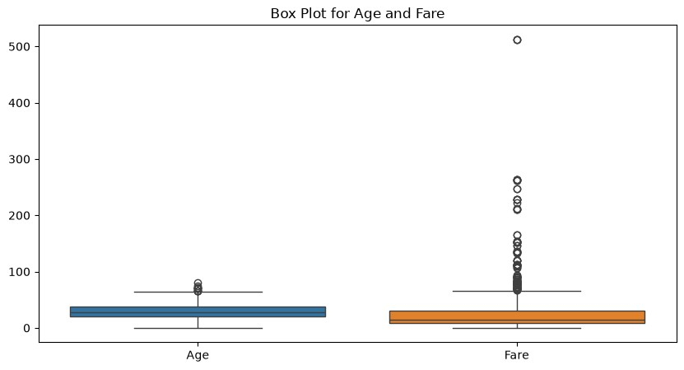
Outliers in Age treated successfully.
New dataset shape: (880, 10)
# Step 8: Normalization
from sklearn.preprocessing import MinMaxScaler scaler = MinMaxScaler()
df[['Age', 'Fare']] = scaler.fit_transform(df[['Age', 'Fare']])
Age and Fare normalized successfully.
Age Fare
4 0.543882 0.015713
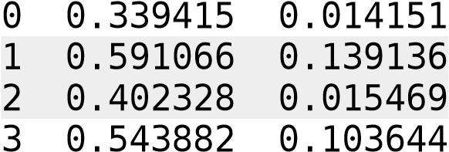
print("Age and Fare normalized successfully.") print(df[['Age', 'Fare']].head())
# Step 9: Feature Engineering
# Create Family Size
df['FamilySize'] = df['SibSp'] + df['Parch'] + 1
# Create Age Group df['AgeGroup'] = pd.cut( df['Age'],

bins=[0, 18, 35, 60, 100],
labels=['Child', 'Young', 'Adult', 'Senior']
)
print("New features created successfully.") print(df[['FamilySize', 'AgeGroup']].head())
New features created successfully.
FamilySize AgeGroup
- 2 Child
- 2 Child
- 1 Child
- 2 Child
- 1 Child
# Step 10: Save the cleaned dataset df.to_csv('titanic_cleaned.csv', index=False) print("Cleaned Titanic dataset saved successfully!")
Cleaned Titanic dataset saved successfully!
QUESTION AND ANSWER

1. Why is data preprocessing important in data analytics?
Data preprocessing is the process of cleaning and transforming raw data before analysis. It is important because real-world data may contain missing values, errors, duplicates, and inconsistent formats. Proper preprocessing improves data quality, accuracy, and reliability of analysis and machine learning models.

2. Methods of handling missing values
Common methods include:
- Removing records: Delete rows containing missing values when only a few values are missing.
- Mean: Replace missing numerical values with the average.
- Median: Replace missing values with the median, especially when data contains outliers.
- Mode: Replace missing categorical values with the most frequent category.
- Forward/Backward fill: Use the previous or next available value, commonly for time-series data.
Example: If marks are 60, 70, missing, 80, the missing value can be replaced by the mean of the available marks.

3. Label Encoding vs One-Hot Encoding
Label Encoding | One-Hot Encoding
Assigns a number to each category | Creates separate columns for each category
Example: Male = 0, Female = 1 | Male → [1,0], Female → [0,1]
Uses a single column | Creates multiple columns
Suitable for ordinal categories | Suitable for nominal categories

4. What are outliers and how do they affect results?
Outliers are observations that are significantly different from most other values in a dataset.
For example, if most salaries are ₹30,000–₹60,000 but one salary is ₹5,00,000, it may be an outlier.
Outliers can:
- Distort the mean.
- Affect statistical analysis.
- Influence regression models.
- Reduce machine learning performance.

5. Normalization vs Standardization
- Normalization: Scales values to a fixed range, usually 0 to 1.
- Standardization: Transforms data so that it has a mean of 0 and standard deviation of 1.
Normalization is useful when features have different ranges, while standardization is commonly used for algorithms that depend on data distribution or distance.

6. Why should duplicate records be removed?
Duplicate records represent the same observation more than once. They can:
- Give incorrect counts.
- Bias statistical results.
- Increase the importance of repeated observations.
- Affect machine learning model training.
Removing duplicates ensures that each observation is represented correctly.

7. What is Feature Engineering?
Feature engineering is the process of creating, modifying, or selecting features from existing data to improve analysis or machine learning performance.
Examples:
- Creating Age from an employee's date of birth.
- Creating Total Spending by adding the prices of all purchases.

8. Preprocessing techniques for IBM HR Employee Attrition dataset
For the IBM HR Employee Attrition dataset, I would apply:
- Missing-value handling → To handle incomplete records.
- Duplicate removal → To avoid repeated employee records.
- Categorical encoding → Convert variables such as Department, Gender, and Job Role into numerical form.
- Feature scaling → Scale numerical features when required by the ML algorithm.
- Outlier detection → Identify unusual values in variables such as Monthly Income or Age.
- Feature selection/engineering → Select useful variables for predicting employee attrition.
These steps improve the quality and performance of the analysis and model.

9. How does poor-quality data affect machine learning?
Poor-quality data can lead to:
- Incorrect predictions.
- Lower model accuracy.
- Biased results.
- Overfitting or underfitting.
- Unreliable conclusions.
Therefore, clean and properly prepared data is essential for building effective machine learning models.

10. Three Python libraries for data preprocessing
Three commonly used Python libraries are:
- Pandas – Data cleaning, missing values, filtering, and manipulation.
- NumPy – Numerical operations and array processing.
- Scikit-learn – Encoding, scaling, normalization, and preprocessing techniques.

